ICT701 – Business Intelligence
Assessment 2: Design of BI System and Data Warehouse
Retail Store Supermarket Analytics Report
Submitted by: [Your Full Name]
Student ID: [Your Student ID]
Date: April 2026

Table of Contents
1. Introduction 3
2. Business Intelligence System Design 3
2.1 BI System Architecture Overview 3
2.2 ETL Pipeline Design 5
3. Data Warehouse Framework 5
3.1 Dimensional Modelling – Star Schema 5
3.2 Rationale for Star Schema 7
4. Visual Analytics and Insights 7
4.1 Key Performance Indicators 7
4.2 Geographic and Branch Sales Analysis 8
4.3 Product Line Performance 9
4.4 Customer Segmentation Analysis 10
4.5 Payment Method Analysis 12
4.6 Temporal Analysis – Transaction Patterns by Hour 12
4.7 Sales vs. Customer Rating Correlation 13
4.8 Quarterly Sales Trend 14
4.9 Slicer Filters and Interactive Drill-Down 15
5. Recommendations and Conclusions 16
5.1 Strategic Recommendations 16
5.2 Conclusion 17
References 18

1. Introduction
The exponential growth of supermarket chains in highly populated urban areas has led to a highly competitive environment, in which data-driven decision-making is critical to business strategy. This report outlines the development of a Business Intelligence (BI) system and a data warehouse system for a multi-store supermarket chain. This report uses a dataset of 1,000 point-of-sale transactions from three branches (X, Y and Z) located in Ballarat, Geelong, and Melbourne for the period from January to March 2022.
This report aims to achieve two things: first, to design a sound BI system and data warehouse following data engineering best practices; and second, to use visual analytics to uncover insights about sales, customer, product, and time-based transaction patterns. The insights are aimed at guiding Retail Store Directors in their strategic planning of store operations, product portfolio management, and customer engagement strategies.

2. Business Intelligence System Design

2.1 BI System Architecture Overview
A Business Intelligence system is an integrated data gathering, storage, processing, and reporting environment. The system architecture for the retail case study is based on a three-tiered approach with a Data Source Layer, an ETL Pipeline, a Data Warehouse, and a Presentation Layer, delivered by Power BI.
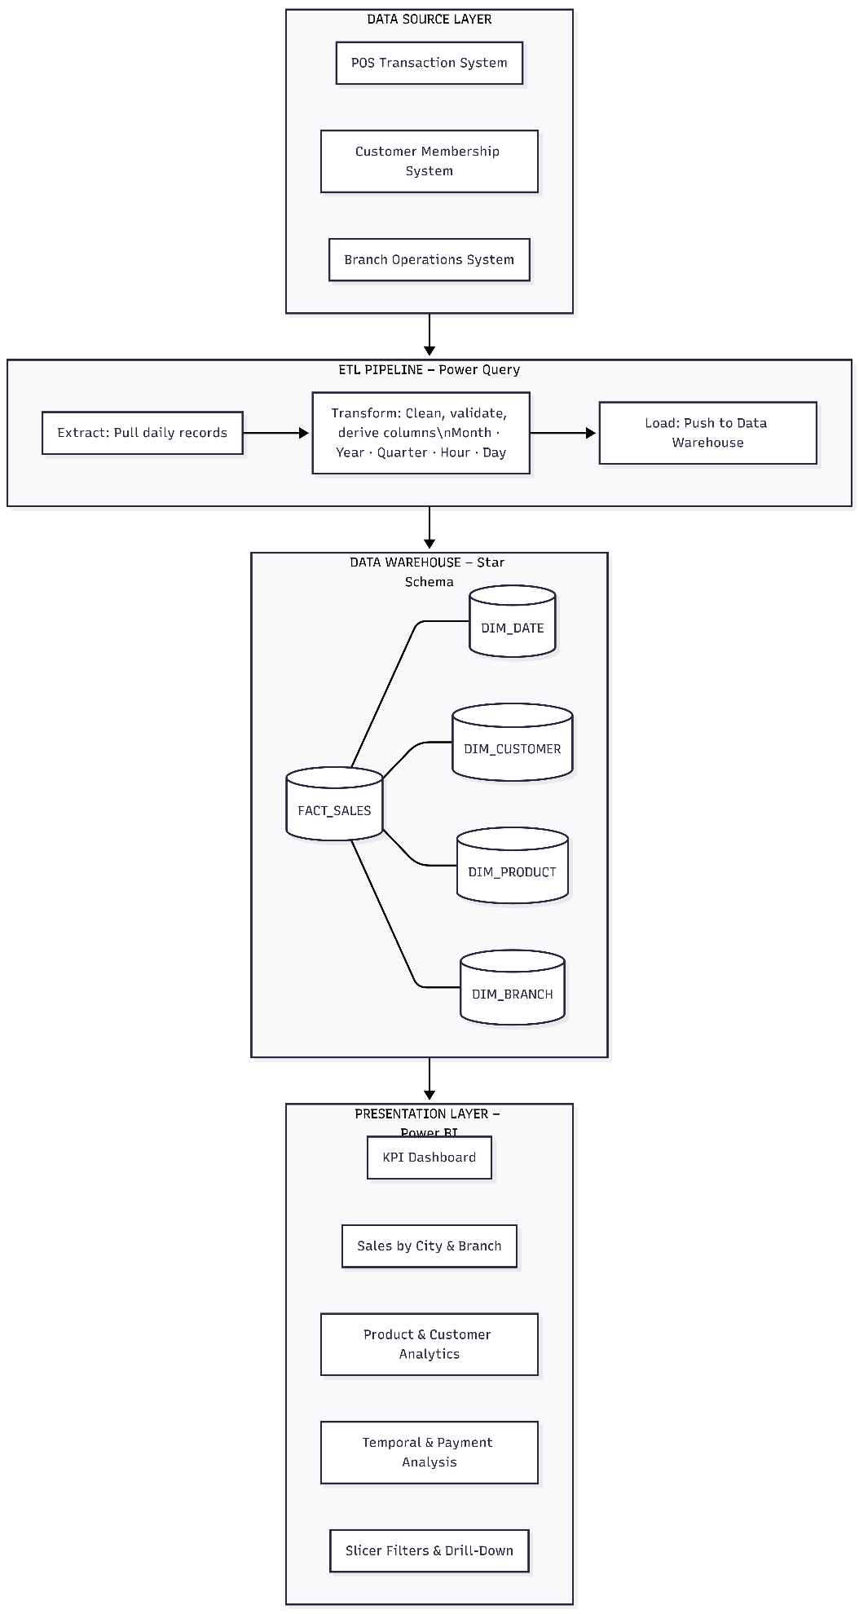
As depicted above, the source of the operational data is the POS Transaction System, the Customer Membership System, and the Branch Operations System. These record transaction, customer, and logistical information. The ETL process is designed using Power Query which extracts data daily, applies data transformation rules, generates temporal features, and loads clean data into a centralised data warehouse. The Presentation Layer then connects the Power BI and the warehouse so that the users can communicate with the dashboards and reports.

2.2 ETL Pipeline Design
The Extract, Transform, Load (ETL) is the heart of the BI system. In the Extract stage, transactions of each day are extracted out of the POS system. Transform phase is characterized by data cleaning, null treatment, removal of duplicates, Year, Quarter, Month, Day, and Hour calculations. The Load phase is when the data is loaded into the star schema data warehouse, which is enriched and cleaned. Power Query was selected as the ETL solution due to its automatic, incremental refreshes as well as its smooth integration with power BI.
The transformation rules applied to this data set include: (1) breaking down the Date field into Month, Quarter and Year; (2) breaking down the Time field into Hour; (3) calculating GrossIncome based on UnitPrice, Quantity and 5% tax rate; and (4) standardising categorical fields (Branch, CustomerType, Gender, ProductLine and Payment) for consistency across the dimensions.
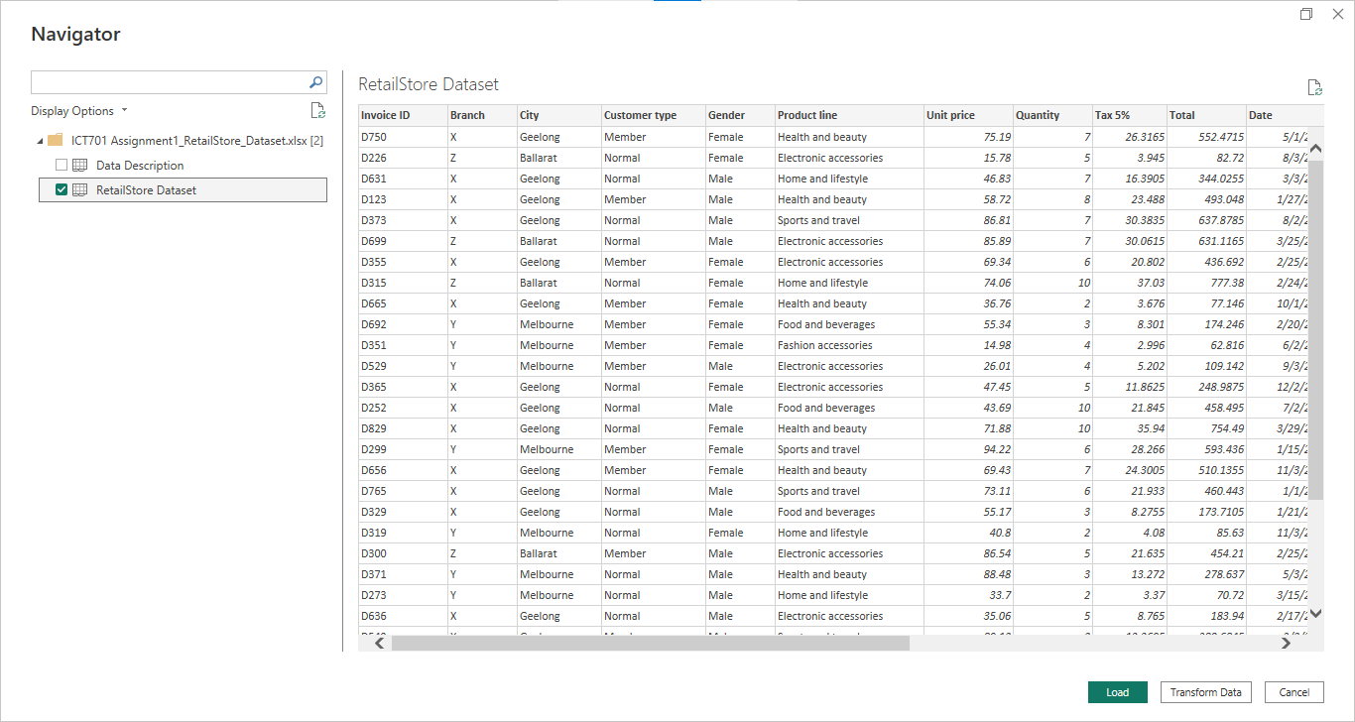

3. Data Warehouse Framework

3.1-Dimensional Modelling – Star Schema
The data warehouse design is Star Schema, which is the standard design for dimensional modelling with analytical use cases because of its simplicity, ease of query and support for business intelligence (BI) applications like Power BI. The schema is made up of a single fact table (FACTSALES) and four-dimension tables (DIMDATE, DIMCUSTOMER, DIMPRODUCT and DIM_BRANCH).

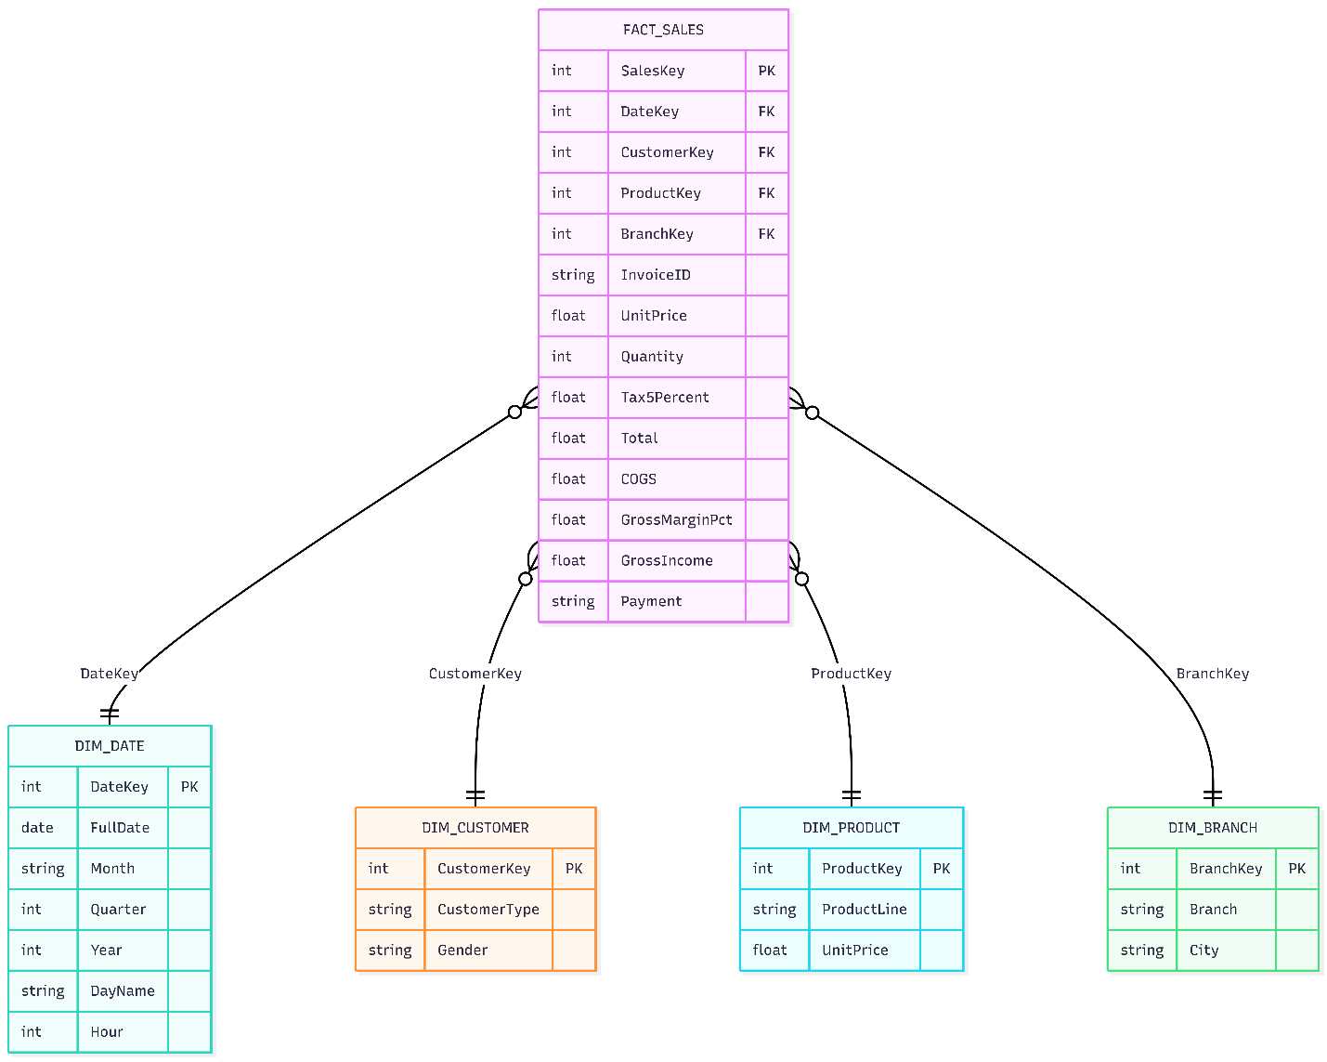
The schema design is summarised in the table below:
Table | Primary Key | Key Attributes
FACT_SALES | SalesKey | DateKey, CustomerKey, ProductKey, BranchKey, InvoiceID, UnitPrice, Quantity, Tax5Percent, Total, COGS, GrossMarginPct, GrossIncome, Payment
DIM_DATE | DateKey | FullDate, Month, Quarter, Year, DayName, Hour
DIM_CUSTOMER | CustomerKey | CustomerType, Gender
DIM_PRODUCT | ProductKey | ProductLine, UnitPrice
DIM_BRANCH | BranchKey | Branch, City
Table 1: Star Schema Summary

3.2 Rationale for Star Schema
The Star Schema was selected as it is preferred over other methods such as Snowflake Schema or Data Vault, for a number of reasons. First, its normalised dimension tables simplify joins and enhance performance, essential for real-time Power BI reports. Second, it is quite easy for business users to understand, and fits the analytical questions being asked (e.g., 'Sales by Branch', 'Sales by Product Line'). Third, the in-memory (VertiPaq) engine in Power BI is specifically designed to work with star schema, making it the ideal fit.
The four-dimension tables support all the analytical dimensions of interest: DIMDATE allows slicing by hour, day, month, quarter, and year; DIMCUSTOMER supports demographic slicing by gender and membership type; DIMPRODUCT supports slicing by product line; and DIMBRANCH supports geographic and branch-level drill-down.

4. Visual Analytics and Insights

4.1 Key Performance Indicators
The KPI dashboard gives a high-level overview of business performance in across all branches for the period January - March 2022. The metrics are shown below:
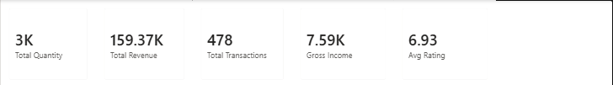
KPI Metric | Value | Interpretation
Total Sales Revenue | $159.37K | Strong revenue across 3 branches
Total Quantity Sold | 3000 units | High product throughput
Gross Income | $7.59K | Consistent profitability
Average Customer Rating | 6.93 / 10 | Moderate satisfaction: improvement needed
Total Transactions | 478 | Solid transactional volume
Table 2: Key Performance Indicators Summary
The mean of 6.93 of 10 is interesting. Although not alarmingly low, it implies that by improving the customer experience (as through queue management, merchandise availability, and training staff to provide good service) customer satisfaction and retention could be enhanced.

4.2 Geographic and Branch Sales Analysis
There are very few differences in sales across the three geographical locations, suggesting a high degree of consistency in branch management and similar market conditions across branches.
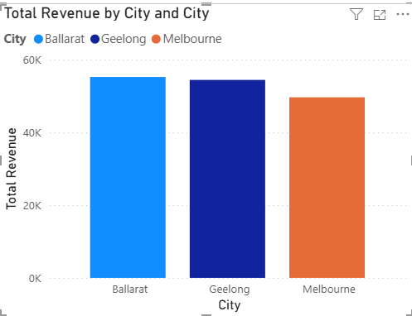
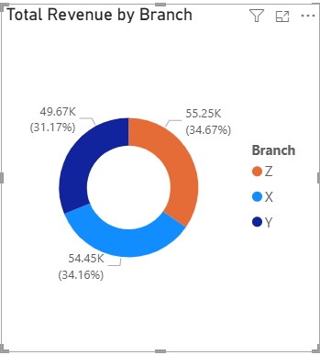
Ballarat (Branch Z) achieved the highest sales at $55.25K (34.67%), marginally ahead of Melbourne/Branch Y ($49.67K, 31.17%) and Geelong/Branch X ($54.45K, 34.16%). The equal distribution across branches implies no branch is performing well or poorly. This symmetry is operationally comforting but also points to the fact that the growth potential might be similar for all branches and localised marketing strategies could offset the symmetry and lead to more localised growth.

4.3 Product Line Performance
The treemap of quantity sold by product line shows the proportion of quantity sold of six different product lines.
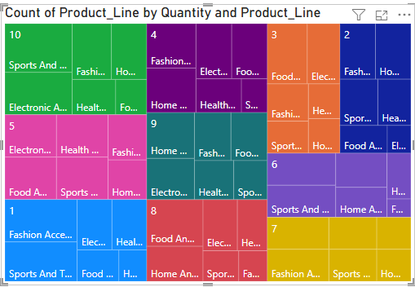
Electronic Accessories was the top category in terms of volume sold, followed by Food and Beverages, Home and Lifestyle, Fashion Accessories, Sports and Travel and Health and Beauty. The high volume of Electronic Accessories sold suggests a high consumer demand, but unit price being different across categories, revenue may not be in line with volume. Managers should determine if adequate space and stock are devoted to the high-turnover items to prevent out-of-stock situations.

4.4 Customer Segmentation Analysis
4.4.1 Gender Distribution
Of the 1,000 transactions, equal numbers of females (229 - 47.91%) and males (259 – 52.09%) have made purchases.

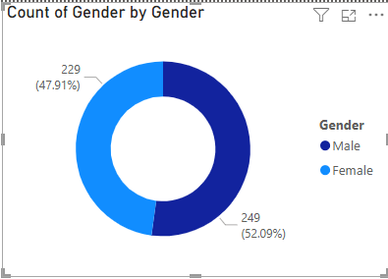
This even gender distribution suggests the supermarket does not favour customers of a particular gender. The gender balance calls for equal focus in marketing and product offerings, without favouring one gender over the other.
4.4.2 Member vs. Normal Customers
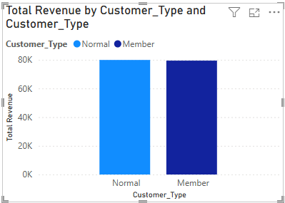
Customers with a membership card had slightly lower total revenue (~$78,000) than Normal customers (non-member) who had no membership card (~$80,000). This indicates that the membership scheme is not exerting a major influence on sales yet. This can be improved: the provision of more appealing membership bonuses, like points or discounts or even pre-emption to promotional offers, will push more customers into the membership program and increased mean average order values.

4.5 Payment Method Analysis
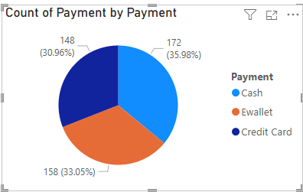
Analysis of product line payments indicates that there is an equal distribution of payments made through Cash, Credit Card, and E-Wallet. E-Wallet payments also represent a new move towards digital payments among consumers, which is in line with the current trends. The retailer must invest in the digital payment system - excellent internet connectivity and presence of POS - to enable a smooth cashless payment.

4.6 Temporal Analysis – Transaction Patterns by Hour
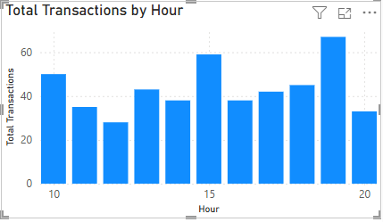
The hourly transaction analysis will be able to give us insights on the kind of customer traffic throughout the operating store hours (10am to 9pm). The maximum transactions are at the closing time (~70 transactions) and once more at in mid day (60 transactions), suggesting periods of maximum shopping. There is a lull in the middle of the day (2pm-4pm) with the lowest number of transactions recorded at 4pm (~30 transactions).
These insights can be used operationally. Staffing levels should mirror these peaks - notably the early evening peak at 7pm - to reduce customer waiting times and enhance customer experience. The period of low volume (mid-afternoon) can be used to create time-limited promotions (e.g., 'Happy Hours') to stimulate traffic during low demand periods.

4.7 Sales vs. Customer Rating Correlation
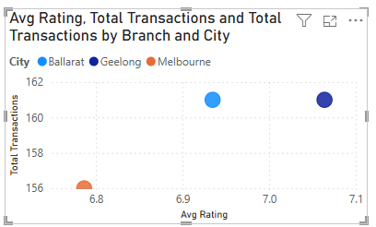
The scatter plot of Sum of Total Sales vs. avg of Customer Ratings per branch shows that Branch X (Geelong) has the highest avg of Ratings aggregate (7.09 approx.) without the highest avg of Sales, while Branch Z (Ballarat) has the highest avg of Sales with a moderate rating (161k approx). Branch Y (Melbourne) has the lowest rating aggregate (~6.8) as well as the lowest sales, indicating that customer experience and sales are related. By enhancing service quality at Branch Y, it may be possible to boost sales.

4.8 Quarterly Sales Trend
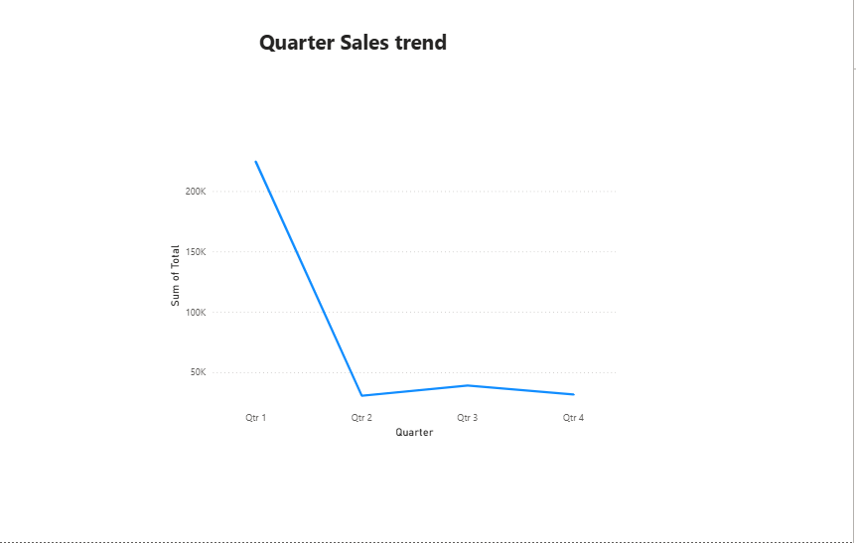
The trend of quarterly sales shows a sharp dip from Quarter 1 (January, ~$220,000) to Quarter 2 (February, ~$35,000) with a slight recovery in Quarters 3 and 4. Among the factors to be taken into account is the fact that the data set spans between January and March 2022 hence the trend in Power BI of a quarter can be regarded more as a trend of a month. The dramatic fall between Q1 and Q2 could be attributed to the fact that January (post-holiday shopping spurt) was replaced with February (reduced consumer spending). The retail directors ought to put this in perspective based on the consumer dip periods and change their marketing approach.

4.9 Slicer Filters and Interactive Drill-Down
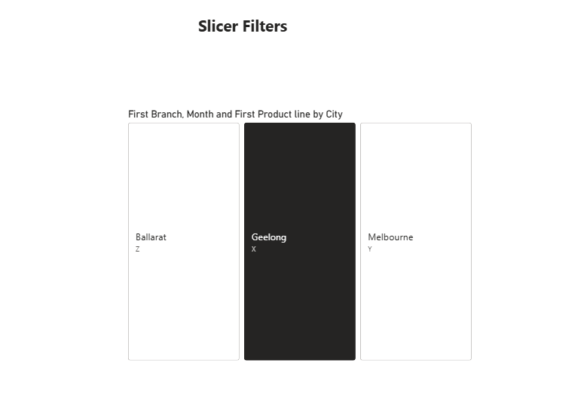
he Power BI dashboard has interactive slicer filters so that users can drill down to City (Ballarat, Geelong, Melbourne), Branch (X, Y, Z) and Month. These enable retail directors to dynamically filter performance measures to a specific branch or period, eliminating the need for different reports. When a user selects 'Geelong', all visuals on the dashboard display data for Branch X, with Branch Managers able to view their own KPIs.

5. Recommendations and Conclusions

5.1 Strategic Recommendations
The following are the recommended insights for the Retail Store Directors based on the visual analytics and insights from this dataset:
- Improve Customer Satisfaction in Branch Y (Melbourne): The systematically lower ratings given by customers at Melbourne's branch indicate aspects of service quality. Specific training for employees, minimising waiting times, and better store organization should be a focus to increase ratings to match Branch X.
- Improve the Membership Programme: The small revenue gap between members and non-members suggests a low-quality membership program. Offering multiple levels of membership, targeted offers and exclusive member discounts will encourage membership and higher value transactions.
- Staff According to Transaction Peaks: The 7pm evening peak (113 transactions) requires sufficient staff. This will ensure that there is sufficient checkout and customer service staff to meet demand, and minimise customer wait times.
- Increase Electronic Accessories and Food & Beverage Stock: The highest quantity product lines (by volume) should be given priority when planning stock levels, display space, and negotiating with suppliers.
- Offer Mid-Afternoon Promotions: The 4pm transaction low point (~75 transactions) is a period of low customer activity. Limited time offers during this period may help boost sales and throughput.
- Upgrade Digital Payment Systems: The increasing use of E-Wallet payments requires investment in secure digital payment systems, contactless payment POS systems, and cyber security measures to facilitate cashless payments.
- Targeted Marketing for Branches: Although the overall performance across branches is the same, there are differences in the cities' demographics and behaviour. For example, Geelong's higher satisfaction score indicates a greater brand loyalty that could be targeted through specific marketing strategies.

5.2 Conclusion
The current report has described a well-built Business Intelligence system and data warehouse design as per the dimensional modelling techniques and a star schema. The ETL system has streamlined the extraction, transformation and loading of transactional data into analytical data structures, allowing Power BI to provide interactive dashboards to the business.
The observations made based on the retail data set are that it is a healthy business whose branches are performing similar, heterogeneous and gender-balanced customer base, demand Electronic Accessories and Food & Beverages. Strategic opportunities include enhancing customer experience (especially at Branch Y), enhancing the loyalty program, and better scheduling employees and promotions to align with high- and low-performance periods.

This BI system architecture suggested in this report is scalable and flexible and can be extended to include other data sources (e.g., e-commerce, social media sentiment) in the future. The retail enterprise can leverage data to its benefit by investing in its data systems and analytics expertise.

References
Kimball, R. & Ross, M. (2013). The Data Warehouse Toolkit: The Definitive Guide to Dimensional Modeling (3rd ed.). John Wiley & Sons.
Microsoft Corporation. (2024). Power BI documentation. https://docs.microsoft.com/en-us/power-bi/
Inmon, W. H. (2005). Building the Data Warehouse (4th ed.). John Wiley & Sons.
Chaudhuri, S., Dayal, U., & Narasayya, V. (2011). An overview of business intelligence technology. Communications of the ACM, 54(8), 88–98.

